CHEMICAL ENGINEERING TRANSACTIONS  VOL. , 2023 | A publication of
The Italian Association
of Chemical Engineering
Online at www.cetjournal.it

Guest Editor: Sauro Pierucci
Copyright © 2023, AIDIC Servizi S.r.l.
ISBN 978-88-95608-98-3; ISSN 2283-9216
Photoelectrochemical Hydrogen Production Using TiO₂ Nano-photocatalysts Electrodeposited on Titanium Electrode
Nadira Salsabila¹, Ragad F. AlShebli¹, Burak Yuzer^{1,2}, ^{1,*}Yusuf Bicer^{1,*}
¹Division of Sustainable Development, College of Science and Engineering, Hamad Bin Khalifa University, Qatar Foundation, Doha, Qatar
²Department of Environmental Engineering, Engineering Faculty, Istanbul University-Cerrahpasa, Istanbul, Turkiye
Ybicer@hbku.edu.qa
Water electrolysis is a method of producing hydrogen that is considered highly efficient, with an efficiency of 70-80% and a high purity of more than 99%. However, it requires a large amount of electricity, about 4.5-5.5 kWh per m³ of hydrogen, and thus there is potential for improvement in making the process more sustainable. This is important as hydrogen is seen as a viable, clean, and sustainable energy carrier, particularly considering global warming and the depletion of fossil fuels. This study investigates photonic hydrogen production by using a photoactive coating on an electrode to provide additional photo-current to the photoelectrochemical cell using solar irradiation and electrical energy. Titanium dioxide (TiO₂) nanoparticles are used as a coating on a Titanium metal substrate. A bath of TiO₂ is prepared using the sol-gel method. The coating is applied by electrochemical deposition in the sol-gel bath. The coated titanium metal is then used as a photocathode in the electrochemical cell, where electrolysis is conducted using sodium sulphate (NaSO₄) solution as the electrolyte. The coating is characterized using a Scanning Electron Microscope (SEM) and X-Ray Diffractometer (XRD) to show if the metal is coated adequately with nanoparticles. Moreover, open circuit potential, linear sweep voltammetry, power potentiometry, and galvanostatic power methods are conducted under light, concentrated light, and no-light conditions to study their electrochemical properties. The photoelectrochemical system’s energy, exergy, and hydrogen generation efficiencies are finally computed based on the data acquired. The result of electrochemical characterization shows that the photo-current generated in the system is doubled under concentrated light conditions, in which the photo-current density is calculated as 12.2 A/m² in concentrated light conditions. Furthermore, SEM results proved that titanium dioxide nanoparticles are present on the coated substrate. From these results, it is determined that by this method, the amount of electrical energy consumption can be reduced due to the additional photo-current achieved by the photoactive electrode.
Keywords: Hydrogen, Photoelectrochemical, Electrodeposition, Electrolysis, Photocathode
  - Introduction
Increased use of non-renewable energy has resulted in two critical environmental issues: global warming and the depletion of fossil fuels. Fossil fuels such as coal, oil, and natural gas are non-renewable resources formed over millions of years from the remains of animals and plants. Fossil fuels are depleted rapidly, which can cause energy costs to rise, reliance on foreign fuel sources, and greater dependence on alternative energy sources. To slow or halt global warming, it is essential to reduce fossil fuel usage and transition to renewable energy sources (Letcher, 2022).

Hydrogen is a chemical element with an atomic number of 1 that serves as an energy carrier, enabling energy storage and transportation. It is produced through electrolysis using various sources, including natural gas, biomass, and water. This versatile compound can be used as a fuel for transportation in fuel cell vehicles and for power generation in hydrogen fuel cell power plants. It is a clean energy source as it doesn’t produce greenhouse gases, making it a potential key player in addressing climate change and reducing greenhouse gas emissions. (Xu et al., 2022). Hydrogen is categorized into various colours, such as blue, grey, brown, black, and green, depending on the technology used to produce it, the energy source, and the environmental impact (Ajanovic et al., 2022). Green hydrogen is created using water and renewable electricity through electrolysis, which splits water into hydrogen (H₂) and oxygen (O₂) with the use of electricity and no carbon emissions (Shiva K., Lim, 2022).

Over the past centuries, water electrolysis technology has undergone continuous development and been used in various industrial applications, with its development divided into roughly five generations. With the recent developments, this technique has an efficiency of up to 70-80% and a high purity of more than 99% water electrolysis (Xu et al., 2022). This method produces hydrogen by applying a direct current to a solution containing electrolytes as shown in Figure 1 (a). As a result of its ability to produce hydrogen in a one-step process, this method is considered among the most efficient in producing hydrogen (Chen et al., 2019; Deng et al., 2019). However, generating 1 m³ of hydrogen requires high amounts of electricity, around 4.5–5.5 kWh, which takes on 80% of the energy produced (Xu et al., 2022). Therefore, there is still room for improvement to make the process more sustainable.
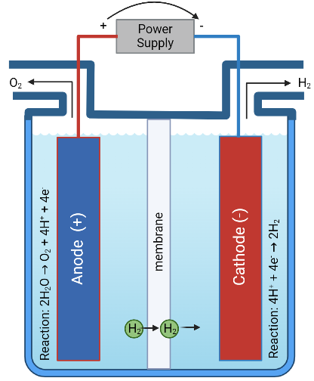  (a) | 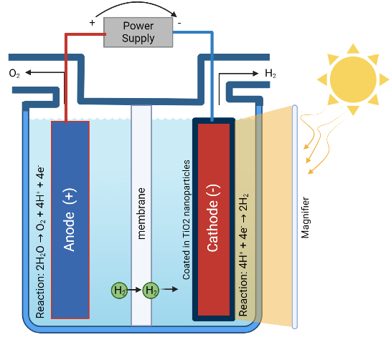  (b)
Figure 1 (a) Electrolysis cell for hydrogen production by water splitting (b) Electrolysis Cell for water splitting using a coated cathode for photoactive energy.

Studies have shown that TiO₂ nanoparticles, which are ultra-fine nanocrystalline particles with a size of 100 nm, have good photocatalytic properties when exposed to UV light (Allen et al., 2021).This study suggests a modification to the electrolysis cell used for producing green hydrogen by applying nanoparticles, such as TiO₂, as a coating on one of the metal electrodes, as depicted in Figure 1(b). These nanoparticles have photoactive properties, which means that they can generate additional photo-current, resulting in a higher rate of hydrogen production, making the system more energy efficient in producing green hydrogen.
  - Methodology
This study aims to investigate hydrogen production via a photoelectrochemical electrolysis process. Firstly, an electrodialysis cell originally purchased from PCCell GmbH in Germany, is modified to construct a photoelectrochemical cell. The anode compartment of the electrodialysis cell is directly used in the system, while the cathode compartment is built with the addition of a quartz glass on a new frame made of polypropylene to ensure light transmission inside the cell. The anode and cathode compartments are separated by an anion-exchange membrane (AEM) with a dimension of 110 x 110 mm and titanium a thickness around 200µm, is also purchased from the same company. A titanium metal plate with 8x8cm (64cm²) in dimension and a thickness of 1 mm is coated with titanium dioxide by using electrodeposition method and placed behind the quartz glass to serve as a photocathode. The schematic representation of the system is given in Figure 2.

The metal is prepared by sanding its surface and washing it with ethanol ready for it to be used for the coating process. The bath prepared is a sol-gel dispersion solution where nanoparticles TiO₂ (40 nm in size) are utilized in the bath as the layer to be coated on the metal. The bath is prepared by adding 2 grams of TiO₂ into a 200 ml volumetric flask. Then adding 50ml acetic acid (CH₃COOH) 100% then filling the flask with deionized water up to the 200 ml mark. Next, the solution is ultrasonicated for 20 mins before adding 2 ml HNO₃. After that, it is magnetically stirred at 300 rpm overnight and added into it 50 ml of ethanol the next day. First, the titanium electrode is coated with TiO₂ nanoparticles using electrodeposition method. During the electrodeposition, titanium metal is used as the cathode while steel is used as its anode. In this configuration cathode will be coated with nanoparticles. After applying 10V for 30 minutes TiO₂ is electrodeposited on the titanium cathode. This metal is then relocated and transferred to the furnace set to be annealed for an hour at 500ºC. In addition, a scanning electron microscope (SEM) is used to analyze the surface to figure out whether the TiO₂ NPs are successfully coated on the surface of titanium electrode.

Moreover, electrochemical characterization of the electrochemical cell is carried out with light, with concentrated light and without light to assess the photoactive electrode and compare the results using a potentiostat (Gamry Instruments Reference 1000). The applied analysis is open circuit potential (OCP), linear sweep voltammetry (LSV), power potentiation (PP), and power galvanostatic methods (PG). OCP chopping is also done to assess the potential difference with the photoactive coated metal for the cases of solar light on and off. All measurements are carried out using the solar simulator at the irradiance of 1000 W/m² and a repeat of the chopping method is also done during PP and PG measurements i.e., at constant voltage and at constant current.
Then, the photo-assisted electrolysis process is carried out with the photoelectrochemical cell. An electrolyte solution of Na₂SO₄ in a water solvent (1 g/L) is used in the cell for all analysis and experiments. The use of this electrolyte solution ensures that hydrogen will be produced in the cathode side with the reactions of the cell as follows:
- Anode Reaction: 2H₂O → O₂ + 4H⁺ + 4e⁻
- Cathode Reaction: 4H⁺ + 4e⁻ → 2H₂
A diagram of how the electrochemical cell works is shown both in Figure 1 and 2, where Figure 2 demonstrates the photoelectrochemical system setup. The electrolysis cell is both ran for an hour long and different analysis is carried out.
Figure 2 The diagram of the photoelectrochemical system setup (IEM: Ion-exchange membrane).

Finally, a thermodynamic analysis is carried out by computing the energy and exergy analysis using Engineering Equation Solver (EES) where mathematical equations are defined as the parameters of the system.
The amount of hydrogen produced is then calculated using the faraday law as current has been defined from previous characterization for all of scenarios. The faraday law is as shown below.
$$w=\frac{e.i.t}{96500} (1)$$
The difference of hydrogen produced between the conditions of with and without solar light, when using a photo active coated cathode, is a result of additional the photo current.
  - Results and Discussion
The SEM image given in Figure 3(a) revealed that the metal surface had some small scratches, which are likely caused by the sanding process prior to the coating. Additionally, the SEM image showed that the TiO₂ nanoparticles are agglomerated to get bigger and the coating is present on the surface of the metal, confirming the successful coating of the titanium metal with TiO₂ nanoparticles. Additionally, it is seen that the metal appeared with blue colour after being coated with the TiO₂ nanoparticles, as shown in Figure 3 (b) and (c). This change in colour may due to the presence of the TiO₂ nanoparticles.
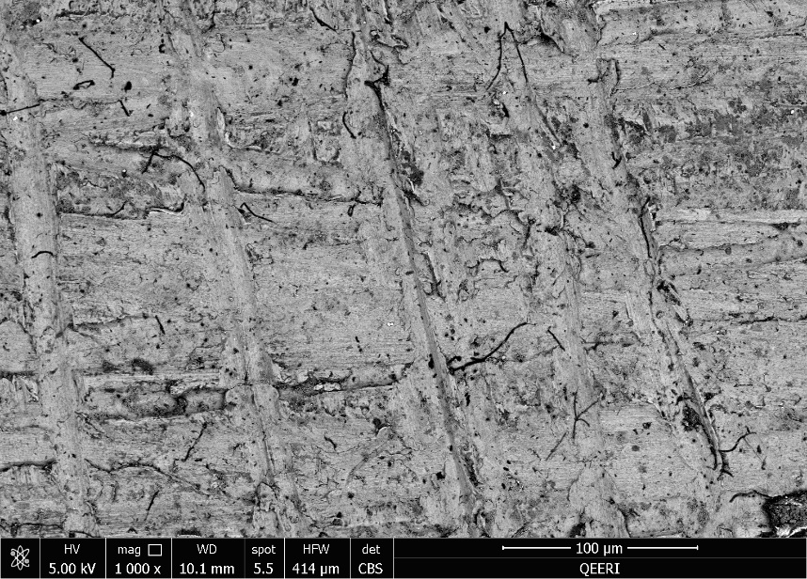  (a) | (b) | (c)
Figure 3 (a) The images of (a) the SEM for the titanium electrode coated with TiO₂ NPs (1000X mag.). (b) The titanium electrode before coating and (c) after coating with TiO₂ NPs.

Next, Energy-dispersive X-ray spectroscopy (EDS) elemental analysis is carried out on the coated titanium metal using both high (20KV) and low (5KV) accelerating voltages. EDS is a technique used to determine the elemental composition of a material by measuring the characteristic X-rays emitted from the sample when it is bombarded with an electron beam. The results of the EDS analysis, shown in Figure 4 indicates that both titanium (Ti) and oxygen (O) particles are present in higher amounts compared to other elements at both accelerating voltages. This suggests that titanium dioxide is present on the surface of the coated metal, as Ti and O are the main constituents of TiO₂. The higher amounts of Ti and O confirmed the successful coating of the titanium metal with TiO₂ nanoparticles. EDS analysis is a valuable technique to determine the elemental composition of a material, and it helped to confirm the presence of TiO₂ on the surface of the coated metal in this experiment.

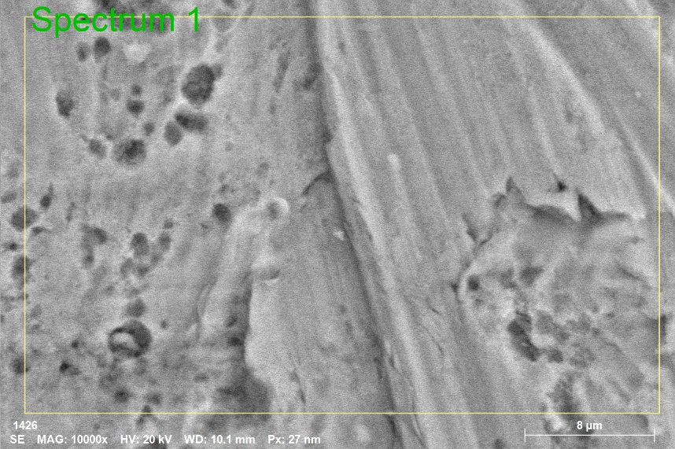  (a) | 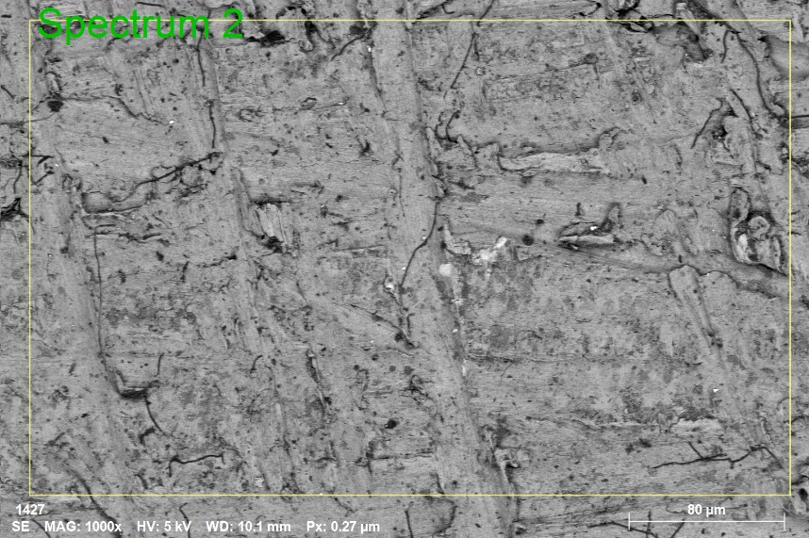  (b)
Figure 4 EDS analysis for titanium electrode coated with TiO₂ (a) spectrum 1 is conducted with 20 kV accelerating voltage and (b) spectrum 2 is conducted with 5 kV accelerating voltage.

The results of the SEM and EDS analysis both confirmed that the titanium metal electrode is successfully coated with TiO₂ nanoparticles. The results of the EDS analysis carried out at 20 kV reveal that the surface of the sample contains a similar amount of oxygen and titanium. The use of a higher X-ray energy allows for deeper penetration into the coating, providing a more comprehensive view of the sample. Conversely, the analysis carried out at 5 kV shows that there are approximately twice as many oxygen atoms as there are titanium atoms on the surface. This finding confirms that the compound formed on top of the metal substrate is indeed titanium dioxide, which is a crucial result for the photo-electrolysis system.

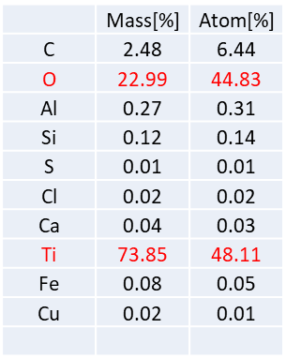
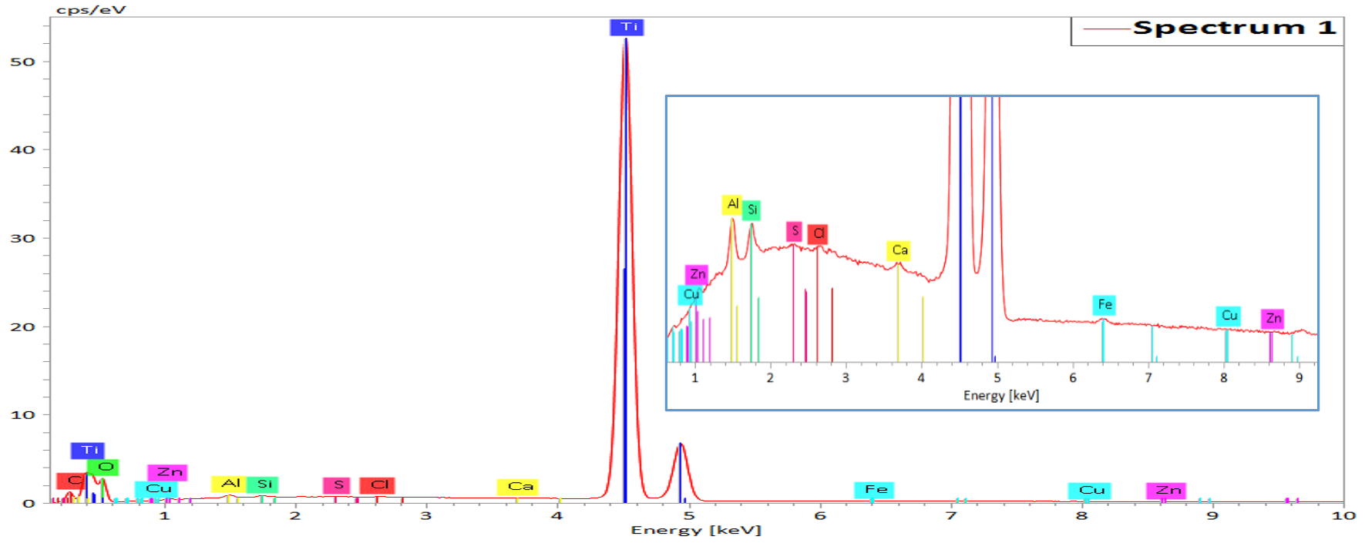
(a)
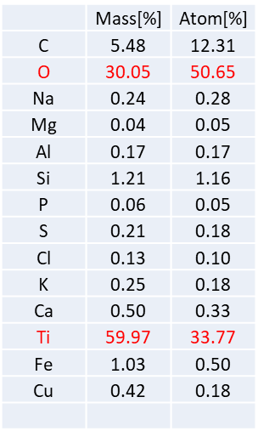
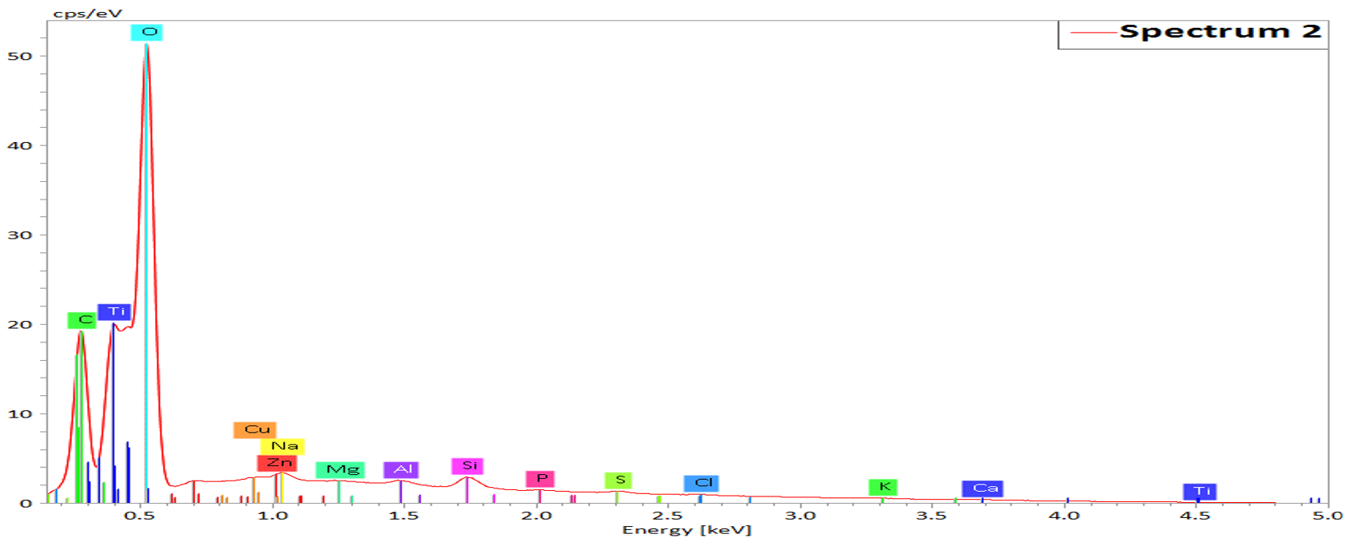
(b)
Figure 5 EDS analysis to monitor elemental distribution of the elements on the metal surface after coating with TiO₂ nanoparticles. (a) spectrum 1 is conducted with 20 kV accelerating voltage and (b) spectrum 2 is conducted with 5 kV accelerating voltage
Next, various electrochemical characterizations are performed to evaluate the effectiveness of the coated titanium metal electrode as a photocathode. The characterizations included open circuit potential (OCP), linear sweep voltammetry (LSV), power potentionstatic (PP) and power galvanostatic (PG). OCP measurement helps to determine the stability and corrosion resistance of the electrodes. In this experiment, OCP is done with the additional of chopping every one minute i.e. alternating between no light conditions and with concentrated light conditions (by using the solar simulator as the source of light) to understand the potential difference from the sun by utilizing the photoactive coating without any external current (As shown in Figure 6 (a)). Results show that there are around a 20-mV difference between the conditions where light is used and light is not used and around another 80 mV difference between using the sun while concentrated and not. This shows that by utilising solar power less resistance is produced in the system making it possible for a higher efficiency.

Moreover, linear sweep voltammetry (LSV) is also done to determine the photocathode’s electrocatalytic activity towards hydrogen evolution. Here, linear sweep voltammetry is carried out with an applied voltage of 0-3V. Results, shown in Figure 6 (b), indicated that by using concentrated solar light on the photo active coating, a higher current density is able to be reached which indicates a higher production rate of hydrogen in the system. Therefore, more energy can be produced during the electrolysis process.

Power potentiometric results are also taken to assess the coated metal and system to measure the efficiency of the water electrolysis process. This type of measurement involves applying a small constant voltage to the system and measuring the resulting current, which can be used to determine the potential of the electrode and the rate of hydrogen evolution. Here, power potentiometric measurements are carried out in two different ways. The first measurement was assessing all three different conditions (with solar light, with concentrated solar light and without light) with an applied potential of 2.5V (Figure 6 (c)). This shows that a higher current density is able to be achieved when concentrated light is used during the electrolysis process even with a constant volt put in the system. This means that by using the solar power more current can run in the system without having to use more energy therefore a faster reaction and a higher production of hydrogen. The second measurements using power potentiometry is done by chopping every 5 minutes, alternating between the conditions with concentrated solar light and no additional light to show the difference in current achieved by the photoactive coating (Figure 6 (d)). Results shows that we can achieve around 0.40 mA/cm² more current by utilizing the solar power.

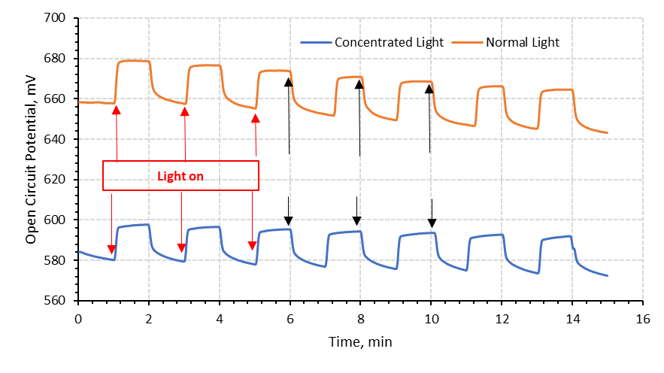  (a)  Light off | (b)
(c) | (d)
(e)
Figure 6 Electrochemical characterization of the system (a) open circuit potential chopping every one-minute, (b) linear sweep voltammetry, (c) potentiometry (d) potentiometry chopping every five minutes (e)galvanostatic chopping every five minutes.

Galvanostatic measurements involve applying a constant electrical current to an electrochemical cell and measuring the resulting voltage or potential. When titanium is coated with titanium dioxide nanoparticles and used as a photocathode, the system can be powered by solar energy, and the galvanostatic measurements would provide information on the efficiency of the photoconversion process. In this case, the titanium dioxide nanoparticles absorb photons from sunlight and use the energy to initiate an electrochemical reaction, which produces electrons that flow through the external circuit. By comparing the galvanostatic measurements of the two systems, it is possible to evaluate the relative performance of each approach. In the case of the electrolysis cell with a titanium cathode, the efficiency of hydrogen generation would be the key performance metric, while for the photo-cathode system, the efficiency of solar energy conversion would be the critical parameter. In this study, galvanostatic measurements are carried out for this reason where the potential difference can be seen through chopping every 5 minutes (Figure 6 (e)). The applied constant current, in this case, is 50 mA and a difference of 0.1 V is seen between the conditions of using photo-current under concentrated solar light and one without the use of solar light.

Next, hydrogen production is calculated using the Faraday law. Therefore, by having the data for the current and understanding the Faraday law the production of hydrogen is calculated as 69.45 µmol/cm².h at concentrated light conditions and 38.59 µmol/cm².h and 33.98 µmol/cm².h at normal solar light conditions and without light conditions, respectively. The utilization of the concentrated light in the system can increase the hydrogen production rate. The system utilising concentrated light exceeds the H₂ production rate of 41.3 µmol/cm².h reported by Tong et al. (2023) for a photoelectrochemical system that used ultra-thin carbon-doped TiO₂ nanotube arrays as the photoanode. Additionally, Ye et al. (2023) showed that a photoelectrochemical system with VO-rich TiO₂ photoanodes achieved a hydrogen production rate of 49.2 µmol/cm². h. These findings suggest that incorporating additional photoactive materials can lead to significant improvements in H₂ production rates.
  - Conclusions
In conclusion, employing titanium dioxide as a coating on the titanium metal would make a photoactive coating layer which allows a regular electrolysis system to function with additional photo-current resulting in a higher production of hydrogen using concentrated solar light (69.45 µmol/cm².h). According to the electrochemical analysis of OCP has also proven that there is around a 20mV difference between the conditions with light and no light and around another 80mV difference between using the sun while concentrated and not where less resistance is found when solar light is utilized. In addition, analysis of power potentiometry (where constant voltage is applied) a higher current density can be produced in the system (around 0.40 mA/cm² more).
Acknowledgments
The authors acknowledge the support provided by Hamad Bin Khalifa University, Qatar Foundation, Qatar.
References
Ajanovic, A., Sayer, M., & Haas, R. (2022). The economics and the environmental benignity of different colors of hydrogen. International Journal of Hydrogen Energy, 47(57), 24136–24154. https://doi.org/10.1016/J.IJHYDENE.2022.02.094
Allen, N. S., Edge, M., Sandoval, G., Verran, J., Catalina, F., Bygott, C., & Kerrod, J. (2021). Research perspectives on the photocatalytic activity of titanium dioxide: Catalytic assessment methods in solution and solid-state in relation to particle surface activity. Polymer Degradation and Stability, 190, 109624. https://doi.org/10.1016/j.polymdegradstab.2021.109624
Chen, L., Nakamoto, R., Kudo, S., Asano, S., & Hayashi, J. ichiro. (2019). Biochar-Assisted Water Electrolysis. Energy & Fuels, 33(11), 11246–11252. https://doi.org/10.1021/ACS.ENERGYFUELS.9B02925
Deng, B., Zhou, L., Jiang, Z., & Jiang, Z. J. (2019). High catalytic performance of nickel foam supported Co2P-Ni2P for overall water splitting and its structural evolutions during hydrogen/oxygen evolution reactions in alkaline solutions. Journal of Catalysis, 373, 81–92. https://doi.org/10.1016/J.JCAT.2019.03.038
Letcher, T. M. (2022). Global warming, greenhouse gases, renewable energy, and storing energy. In Storing Energy (pp. 3–12). Elsevier. https://doi.org/10.1016/B978-0-12-824510-1.00011-8
Shiva Kumar, S., & Lim, H. (2022). An overview of water electrolysis technologies for green hydrogen production. Energy Reports, 8, 13793–13813. https://doi.org/10.1016/J.EGYR.2022.10.127
Tong, M.-H., Wang, T.-M., Lin, S.-W., Chen, R., Jiang, X., Chen, Y.-X., & Lu, C.-Z. (2023). Ultra-thin carbon doped TiO2 nanotube arrays for enhanced visible-light photoelectrochemical water splitting. Applied Surface Science, 623, 156980. https://doi.org/10.1016/j.apsusc.2023.156980
Xu, X., Zhou, Q., & Yu, D. (2022). The future of hydrogen energy: Bio-hydrogen production technology. International Journal of Hydrogen Energy. https://doi.org/10.1016/J.IJHYDENE.2022.07.261
Ye, Y., Liao, B., Li, M., Mai, M., Zhang, L., Ma, L., Lin, D., Zhao, J., Chen, D., & Ma, X. (2023). Boosting photoelectrochemical chlorine and hydrogen production with oxygen vacancy rich TiO2 photoanodes. Journal of Alloys and Compounds, 947, 169480. https://doi.org/10.1016/j.jallcom.2023.169480

